# Purpose

This release note covers the changes to Carrier servers to fix ESR mentioned in below table

| ESR | Description | PTC TS # (if any) |
| --- | --- | --- |
| ESR 24214 | **Online Chat Not Working** | - |

# Revision History

Document revision history is controlled by [http://pds.ptc.com](http://pds.ptc.com/) & [http://windchill.carrier.utc.com](http://windchill.carrier.utc.com/) (Carrier’s Production Server).

Carrier:

<http://windchill.carrier.utc.com/Windchill/app/#ptc1/tcomp/infoPage?oid=VR%3Awt.doc.WTDocument%3A1568659710>

PDS PTC:

# Change History

| Date | Revision | Technician | Description of change and a link to affected section |
| --- | --- | --- | --- |
| 21/01/2013 | A.1 | Adarsh Sambhav | Online Chat Not Working |

# Issue Summary

This is related to Online chat support link. Chat link is working fine in Mozilla browser but with IE browser it gives only a blank page.

# Deployment Status

Below table contains current status of these changes, this tables will be updated by Infrastructure Teams

|  |  |  |  |
| --- | --- | --- | --- |
| **Servers** | **Development** | **Staging** | **Production** |
| **Deployed by** |  |  |  |
| **Deployed Date** |  |  |  |
| **Validated by** |  |  |  |
| **Validated date** |  |  |  |

# Check List

Below are the lists of items that need to be verified before scheduling deployment on test and production server.

|  |  |  |  |
| --- | --- | --- | --- |
| **Check-list** | **Development** | **Staging** | **Production** |
| **Files updated to SVN** |  |  |  |
| **Included manual recovery steps** |  |  |  |
| **Included validation Steps** |  |  |  |
| **Validation Confirmation from User** |  |  |  |
| **Database Export required** |  |  |  |
| **LDAP Export required?** |  |  |  |
| **Windchill codebase Backup?** |  |  |  |
| **Selected Files Backup** |  |  |  |
| **Change Control** |  |  |  |
| **Windchill Start/Stop required?** |  |  |  |

# Resolution

Below are the different steps involved during deployment.

## Specify the SVN Location

All modified/updated files downloaded from

[WC10_DEV](https://sspsvn.ptc.com/Carrier/PDSOptimization/branches/WC10_DEV)

## List of all OOTB & Custom files modified to resolve this issue

Below are the list of all OOTB & Custom files modified to resolve this issue:

|  |
| --- |
| **File Name** |
| <wt_home>/codebase/config/actions/ custom-actions.xml |
|  |

## List of all new file/files added to resolve this issue

|  |
| --- |
| **File Name** |
| <wt_home>/codebase/netmarkets/jsp/ext/carrier/wc/chat/chatLink.jsp |
|  |

## Manual changes before deploying changes

## Take a backup of below file

<wt_home>/codebase/config/actions/ custom-actions.xml

## Deployment procedure

Replace below files from [WC10_DEV](https://sspsvn.ptc.com/Carrier/PDSOptimization/branches/WC10_DEV) to below location:

<wt_home>/codebase/config/actions/ custom-actions.xml

1. Copy below files from svn to below location:

<wt_home>/codebase/netmarkets/jsp/ext/carrier/wc/chat/chatLink.jsp

1. Clear the Tomcat cache.
2. Start the Tomcat and Windchill servers.

## Manual changes after deployment

N/A

# Validation

1. Login to Windchill. Go to Quick Links-🡪 Online Support.
2. Open the link. Below window should appear.

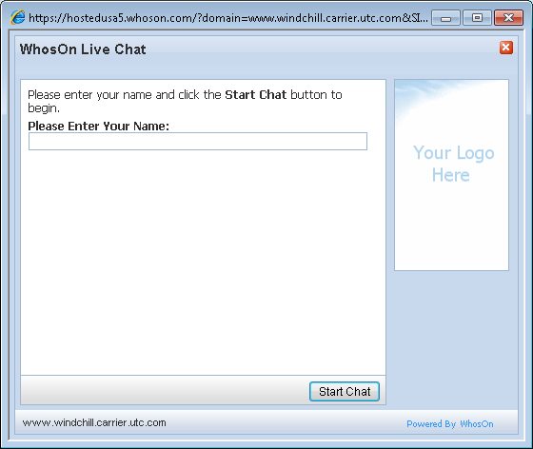

# Steps to Restore (On Failure/if Needed)

1. Delete the above mentioned chatLink .jsp file and revert the custom-actions.xml file.
2. Clear Tomcat and windchill cache.
3. Restart Method server.

# Issues encounter during deployments (If any)

Details of any issues faced during deployment should be captured over here.

# Server Administration procedures

The detailed steps of different server administration procedures are captured and available in Production server administration document available at PDS Site (link) and Carrier site (link).This includes procedures on taking different component backups, stopping and starting different components, steps to clear caches and server restore procedures.

# Contacts

Details of all the contacts who are involved in different phases of deployments will be listed over here.